**Lab 9 Screenshots and Relevant Pictures:**

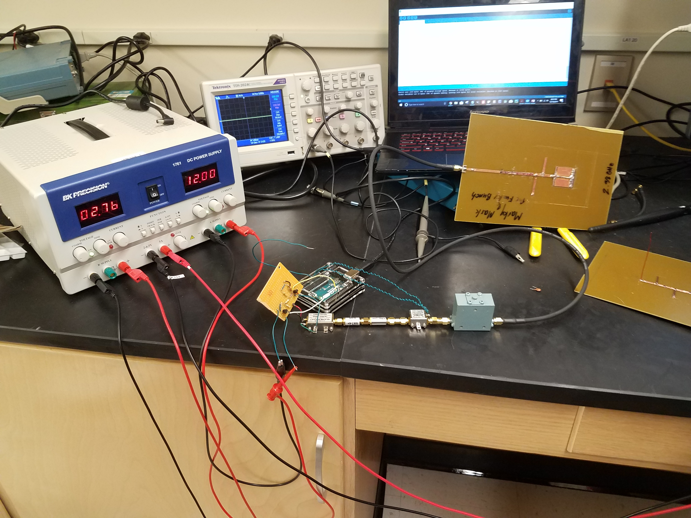

**Figure 1.** Above is a picture of the overall final circuit setup.

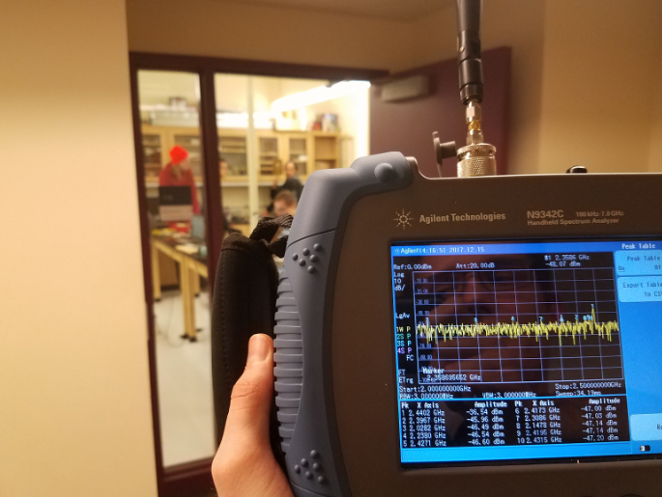

**Figure 2.** This picture shows the transmitted signal labeled as 1, all the way out of the door.

**Table 1**. The expected vs. measured value for the stub dimensions on the patch antenna.

|  |  |  |  |
| --- | --- | --- | --- |
|  | **Expected** | **Measured** | **Percent Error** |
| **Length** | 30.14 mm | 31.00 mm | 2.85 % |
| **Width** | 30.14 mm | 27.59 mm | 8.46 % |
| **1st Stub Length** | 6.97 mm | 24.48 mm | 251 % |
| **2nd Stub Length** | 10.62 mm | 29.90 mm | 181 % |

**Table 2**. The pre-tune, 1st, and 2nd stub characteristic values of the patch antenna.

|  |  |  |  |
| --- | --- | --- | --- |
|  | **Before tuning** | **After the 1st Stub** | **After the 2nd stub** |
| **Impedance** | 36 + j(45.2) Ω | 79.97 + j(10.01) Ω | 49.56 + j(3.68) Ω |
| **SWR** | 2.9 | 1.65 | 1.05 |
| **Return Loss** | 6.41 dB | 12.2 dB | 32.69 dB |

**Table 3**. The expected vs. the final tuned characteristic values of the patch antenna.

|  |  |  |  |
| --- | --- | --- | --- |
|  | **Expected Values** | **After the 2nd stub** | **Percent Error** |
| **Impedance** | 50 Ω | 49.56 + j(3.68) Ω | 0.88 % |
| **SWR** | 1 | 1.05 | 5 % |
| **Return Loss** | Infinite dB | 32.69 dB | N/A  It’s high enough |
| **Resonant Point** | 2.4 GHz | 2.388 GHz | 0.5 % |

**////////////////////////////////////////**

**// Manchester Send Data Code**

**// Microwaves**

**// Zach Wilson**

**// 11/16/2017**

**// Rev_1**

**////////////////////////////////////////**

/*

This is Manchester for "110"

delta-t delta-t delta-t

|----------|-----------|-----------|

_____ _____ _____

| | | | | |

| | | | | |

____| |_____| |_____| |_____

*/

#define DELTA (1250) // micro-seconds

#define HALF_DELTA (DELTA/2) //half period

#define ARRAY_LENGTH (9)

#define DATA_PIN (7)

#define POWER_PIN (8)

#define TEST_HIGH_PIN (2)

#define TEST_LOW_PIN (4)

//bool dataArray[ARRAY_LENGTH];

bool dataArray[ARRAY_LENGTH] = {1, 1, 0, 0, 1, 0, 0, 1, 0};

bool test = false;

void setup()

{

pinMode(DATA_PIN, OUTPUT);

pinMode(POWER_PIN, OUTPUT);

pinMode(TEST_HIGH_PIN, OUTPUT);

pinMode(TEST_LOW_PIN, OUTPUT);

digitalWrite(TEST_HIGH_PIN, LOW);

digitalWrite(TEST_LOW_PIN, LOW);

digitalWrite(POWER_PIN, LOW);

digitalWrite(DATA_PIN, LOW);

}

void loop()

{

// if (!test)

// {

//

// // Serial.println("-------");

//

// for (int x = 0; x < ARRAY_LENGTH; x++)

// {

//

// digitalWrite(POWER_PIN, HIGH);

//

// if (dataArray[x] == HIGH)

// {

// digitalWrite(DATA_PIN, HIGH);

// digitalWrite(TEST_HIGH_PIN, HIGH);

// digitalWrite(TEST_LOW_PIN, LOW);

// delayMicroseconds(HALF_DELTA);

// digitalWrite(DATA_PIN, LOW);

// digitalWrite(TEST_LOW_PIN, HIGH);

// digitalWrite(TEST_HIGH_PIN, LOW);

// delayMicroseconds(HALF_DELTA);

// }

//

// else

// {

// digitalWrite(DATA_PIN, LOW);

// digitalWrite(TEST_LOW_PIN, HIGH);

// digitalWrite(TEST_HIGH_PIN, LOW);

// delayMicroseconds(HALF_DELTA);

// digitalWrite(DATA_PIN, HIGH);

// digitalWrite(TEST_HIGH_PIN, HIGH);

// digitalWrite(TEST_LOW_PIN, LOW);

// delayMicroseconds(HALF_DELTA);

// }

//

// test = true;

// }

digitalWrite(TEST_HIGH_PIN, LOW);

digitalWrite(TEST_LOW_PIN, LOW);

digitalWrite(POWER_PIN, LOW);

// }

// // For Testing without the Receiver group

// delay(1000);

// digitalWrite(POWER_PIN, HIGH);

// digitalWrite(DATA_PIN, HIGH);

// delay(3000);

// digitalWrite(DATA_PIN, LOW);

// delay(3000);

// digitalWrite(DATA_PIN, HIGH);

// delay(3000);

// digitalWrite(POWER_PIN, LOW);

// while (1);

// Square Wave Test:

digitalWrite(POWER_PIN, HIGH);

digitalWrite(DATA_PIN, HIGH);

delay(3000);

digitalWrite(DATA_PIN, LOW);

delay(3000);

digitalWrite(DATA_PIN, HIGH);

delay(3000);

digitalWrite(POWER_PIN, LOW);

while(1);

}